**User Manual for ChainIDentity**

Brandon Magaña Avalos   
Student ID - 0244582   
[bavalosmm@gmail.com](mailto:bavalosmm@gmail.com)  
Student of ISGC

Juan Carlos López Pimentel   
[clopezp@up.edu.mx](mailto:clopezp@up.edu.mx)   
Research Professor - Faculty of Engineering

Index

User Manual for the ChainIDentity 3

1. Introduction 3

2. Initial Setup and Access 3

2.1 Accessing the Front-End Interface 3

2.2 Registering the First Government User 3

3. Authentication and Guest Access 4

3.1 Logging In 4

3.2 Guest Capabilities 5

4. Government Dashboard 5

4.1 Viewing All Registered Users 5

4.2 Registering a New User 5

4.3 Consult user information 7

5. User Interface Overview 7

5.1 Main Page and Search 7

5.2 Role-Based Permissions 8

6. Digital Identity Service 8

6.1 Personal Dashboard 8

6.2 Linking Objects and Records 9

7. Birth Certificate Service 10

7.1 Creating a Birth Certificate 10

7.2 Accessing the Certificate 11

8. Scholar Curriculum Service 13

8.1 Assigning Student Identity 13

8.2 Adding Academic Records 13

8.3 Student and Guest Access 14

9. Summary and Future Integration 14

Appendix — Figures 15

# User Manual for the ChainIDentity

## 1. Introduction

ChainIDentity is a decentralized software platform designed to tokenize entities, digital and physical objects. It utilizes blockchain smart contracts to link users digital tokens with unique objects or real-world assets such as vehicles, birth certificates, or academic credentials.

This document is intended to interact with the front-end system. It assumes the system has been deployed and running.

All interfaces are fully responsive and support both light and dark modes, which users can select based on their preference. Figure 1 illustrates the interface in dark mode, while Figure 2 presents the same interface in light mode.

Figure 1. Dark mode enable. Figure 2. Light mode enable.

## 2. Initial Setup and Access

### 2.1 Accessing the Front-End Interface

Once deployed, the platform is accessible through the Users Front at: http://localhost:5512 (local development) or http://<assigned-ip>:5512 (remote access). In this manual we will use the local URL.

Navigate to */registergovernment* to begin the system. This is the first mandatory step.

### 2.2 Registering the First Government User

Go to http://localhost:5512/registergovernment endpoint, a form is presented with three input fields:

-Email  
-Password   
-Token Identity, e.g., 0x2CFcBB9Cf2910fBa7E7E7a8092aa1a40BC5BA341 (You can leave the default value), obtained from Ganache or another blockchain wallet.

This user becomes the system’s root authority and can create all subsequent users and services.

Fill out the fields shown in Figure 3 and submit the form. Once registration is completed, the system, will pop-ups 2 alerts as shown in Figure 4, then route /registergovernment is disabled automatically redirects to the login page. This government user is essential to the system functionality, without it, no other service can operate.

Figure 3. Government initial form. Figure 4. Successful registration.

## 3. Authentication and Guest Access

### 3.1 Logging In

Upon redirection, the login screen is displayed (Figure 5). There are 2 options to log in, log in with their credentials or continue as guests. The first time log in with government credentials.

Figure 5. Login form of Users system.

Guests can read only public information.

If the password or email is incorrect during login process the alert shown in Figure 6 will appear in any service.

Figure 6. Login fail attempt.

### 3.2 Guest Capabilities

Guests can use the search bar to find public data by entering a token address or user email and pressing Enter or clicking the magnifying glass icon. The front-end is illustrated in Figure 7.

Figure 7. User search bar.

Guests cannot: View private data, register new users, or modify the system state

## 4. Government Dashboard

### 4.1 Viewing All Registered Users

Government users gain access to the Users Tab, which contains a searchable table with registered users. Each row includes Email, Token Address, Type, and Digital Identity Address.

The government can browse the registry, as shown in Figure 8.

Figure 8. User List

### 4.2 Registering a New User

In the Registration Tab, the government may create new users. The form contains: email, password, user type, token address, and creator address (auto-filled from the logged-in Government) visually shown in Figure 9. (You can obtain addresses from the ganache container, without using already used addresses)

Figure 9. Registration form.

The user types are characterized by the options shown in Figure 10. The Government is the only entity capable of creating other government accounts (i.e., users with the same permissions). The admin has limited functions but still possesses higher privileges than the regular users. Users and Educational Administrators share similar levels of access, with the least privileges overall. However, Educational Administrators are the only users authorized to manage the Scholar Curriculum System.

Figure 10. User types.

Submitting this form a new Digital Identity Contract is created, and assigned to the filled user. The token will serve as the record for linking documents and verifying identity. See Figure 11 for a sample of successful registration.

Figure 11. Successful registration alert.

### 4.3 Consult user information

The user consultation operates as described in Section 5.1, referring to the main page, and in Section 5.2, which will explain the key differences between other users and the government.

## 5. User Interface Overview

### 5.1 Main Page and Search

Upon login, users land on the Main User Interface. At the top right you can see a search bar (previously shown at Figure 7). Clicking into the bar and typing a known token address or user email, followed by pressing Enter or clicking the icon, it retrieves public metadata stored on the user’s contract — e.g., the name, token direction, or contract origin (as shown in Figure 12 and Figure 13). As well, if the field is empty, by pressing enter or clicking the icon, will display the service information like the government of the service (Figure 14).

Figure 12. Information obtained from user1@user1.com

Figure 13. Information obtained from user1@user1.com using the token address.

Figure 14. Information displayed from the empty search bar.

If the user is an admin or official government, on the left interface menu expands (Figure 15) to include access to:

- A list of all users

- A user registration form

- A Users consult information

Figure 15. Extended menu.

### 5.2 Role-Based Permissions

Each role has unique access capabilities as shown in the following table:

| Role | View  Public Data | View  Private Data | Register Users | Create Records | Link Objects |
| --- | --- | --- | --- | --- | --- |
| Guest | ✅ | ❌ | ❌ | ❌ | ❌ |
| Registered User | ✅ | ✅ (self only) | ❌ | ❌ | ✅ (self) |
| Government | ✅ | ✅ | ✅ | ✅ | ✅ |

Table 1. Comparison between the different roles.

## 6. Digital Identity Service

Access the Digital Identity Service via http://localhost:5511

### 6.1 Personal Dashboard

Each registered user has access to the Digital Identity Interface, which serves as their dashboard. From here, users can view public and private data associated with their identity and also search other public identities using token address.

For example, by typing a user’s public token in the search bar (similar to the process in Figure 7), one can preview their public information. This interface is illustrated in Figure 16, by clicking on the 'More Information' link, you can display the details of the token being logged.

Figure 16. Search section for digital identity.

Figure 17. Information obtained from Birth Certificate information in the digital identity address.

### 6.2 Linking Objects and Records

Once logged, users can link new tokens (representing physical objects or records) to their identity token by submitting the token address to the form. The token might correspond to: A car, birth certificate, diploma or achievement, etc. Figure 18. A token example can be obtained following the service example from either section 7 or 8,

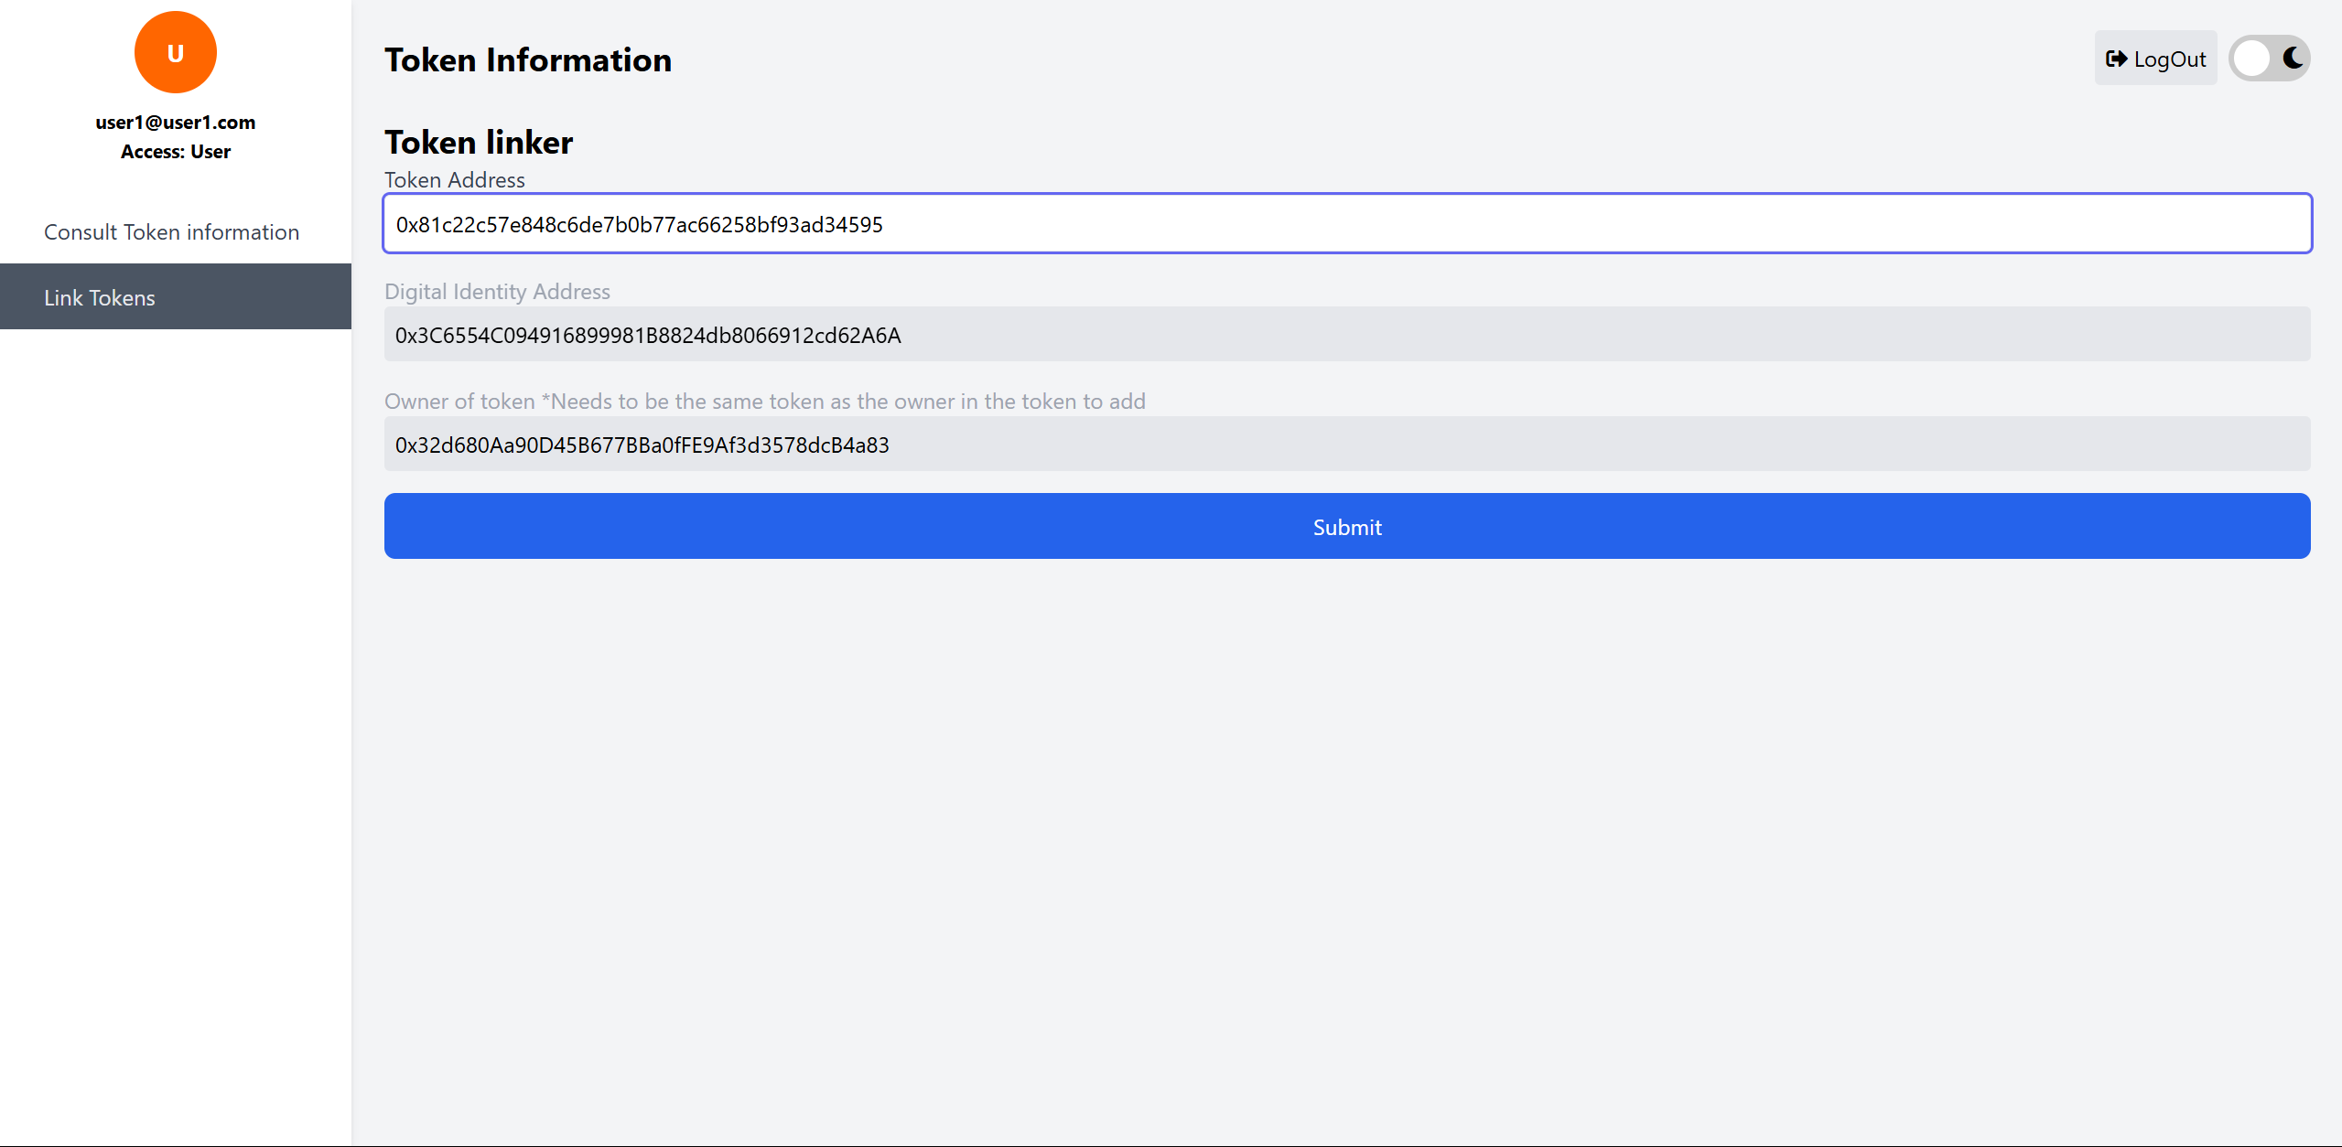

Figure 18. Token Linker.

The form validates the token existence and binds it to the user’s identity. This enables decentralized ownership verification, when the right link is introduced, on screen will appear the next notification “Linked Successfully” (Figure 19.), after that, the address will appear with its name on the search section in the “Consult Token Information” tab, as shown in Figure 20.



Figure 19. Linked Successfully.

Figure 20. New certificate stored on the digital identity.

## 7. Birth Certificate Service

This service allows the government to issue Digital Birth Certificates.

Access the Digital Identity Service via http://localhost:5510

### 7.1 Creating a Birth Certificate

Once logged, the government can select a user without a birth record, input personal data (full name, parents, birthplace, etc.), and assign token addresses to the parents (if available) Figure 21.

Figure 21. User list, to create a new certificate.

Figure 22 shows the form in use to create a certificate. After all filled, the birth certificate is created and needs to be linked to the digital identity token for it to be stored. Figure 20 shows this form in use linking the certificate to the digital identity.

Figure 22. Birth Certificate form.

### 7.2 Accessing the Certificate

Represented in Figure 23, Figure 25, and Figure 26, one can see the different viewing that each user has, and the government having an extra function (Figure 24), in addition all users can view information of the contracts, but what they can see in the contract details depends on their role.

Figure 23. Governments main view.

Figure 24. Edit address function.

Figure 25. Users main view.

Figure 26. Guests main view.

|  |  |  |
| --- | --- | --- |
| Users can view their own birth certificate, both public and private fields. Figure 27. | Guests can only view public data, e.g., name and sex. Figure 28. | Governments can view all data. Figure 29. |
| Interfaz de usuario gráfica, Texto, Aplicación  El contenido generado por IA puede ser incorrecto.  Figure 27. Users form view. | Interfaz de usuario gráfica, Texto, Aplicación  El contenido generado por IA puede ser incorrecto.  Figure 28. Guests form view. | Interfaz de usuario gráfica, Texto, Aplicación  El contenido generado por IA puede ser incorrecto.  Figure 29. Governments form view. |

## 8. Scholar Curriculum Service

This service tokenizes academic achievement. It requires a user representing an educational institution, which must be registered by the government.

Access the Scholar Curriculum Service via http://localhost:5513

### 8.1 Assigning Student Identity

Once logged, the institutions may register verified individuals (i.e., those with valid birth certificates) to become students by filling a unique Student Id and the student Birth certificate, Figure 30.

Figure 30. Create a scholar curriculum form.

### 8.2 Adding Academic Records

School admins can add records such as enrollments, degrees or diplomas, and achievements (e.g., project awards) seen in Figure 31 and the form in Figure 32. Figure 33 demonstrates how an institution enters student data.

Figure 31. Achievements section.

Figure 32. Add achievement form. Figure 33. Achievement form filled.

In the same section, the available achievements can be viewed to display only the ones the student has earned, as shown in Figure 34. Following this, referring to Figure 35, you can see how the details are displayed after pressing the “Achievement Details” button.

Figure 34. Achievements updated.

Figure 35. Achievement details example.

### 8.3 Student and Guest Access

* Students can log in to view their achievements Figure 36.
* Guests can search for students using their token and view only public achievements. Figure 37.

Figure 36. Scholar curriculum home, Students view.

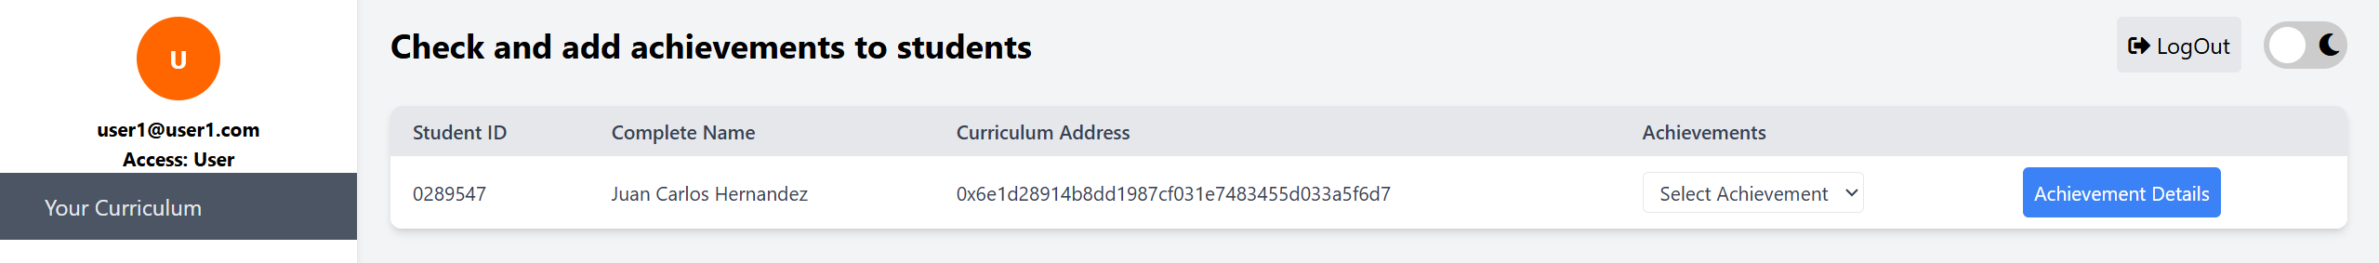

Figure 37. Scholar curriculum home, Guests view.

## 9. Summary and Future Integration

This manual has documented the full flow of the Digital Identity system, including:

- Initialization of the government user

- Role-based interaction - Linking of records

- Demonstration use cases: Birth Certificates and Academic Records

## Appendix — Figures

Figure 1. Dark mode enable. Figure 2. Light mode enable. 3

Figure 3. Government initial form. Figure 4. Successful registration. 4

Figure 5. Login form of Users system. 4

Figure 6. Login fail attempt. 5

Figure 7. User search bar. 5

Figure 8. User List 5

Figure 9. Registration form. 6

Figure 10. User types. 6

Figure 11. Successful registration alert. 7

Figure 12. Information obtained from user1@user1.com 7

Figure 13. Information obtained from user1@user1.com using the token address. 7

Figure 14. Information displayed from the empty search bar. 7

Figure 15. Extended menu. 8

Figure 16. Search section for digital identity. 9

Figure 17. Information obtained from Birth Certificate information in the digital identity address. 9

Figure 18. Token Linker. 10

Figure 19. Linked Successfully. 10

Figure 20. New certificate stored on the digital identity. 10

Figure 21. User list, to create a new certificate. 11

Figure 22. Birth Certificate form. 11

Figure 23. Governments main view. 11

Figure 24. Edit address function. 12

Figure 25. Users main view. 12

Figure 26. Guests main view. 12

Figure 27. Users form view. 12

Figure 28. Guests form view. 12

Figure 29. Governments form view. 12

Figure 30. Create a scholar curriculum form. 13

Figure 31. Achievements section. 13

Figure 32. Add achievement form. Figure 33. Achievement form filled. 13

Figure 34. Achievements updated. 14

Figure 35. Achievement details example. 14

Figure 36. Scholar curriculum home, Students view. 14

Figure 37. Scholar curriculum home, Guests view. 14